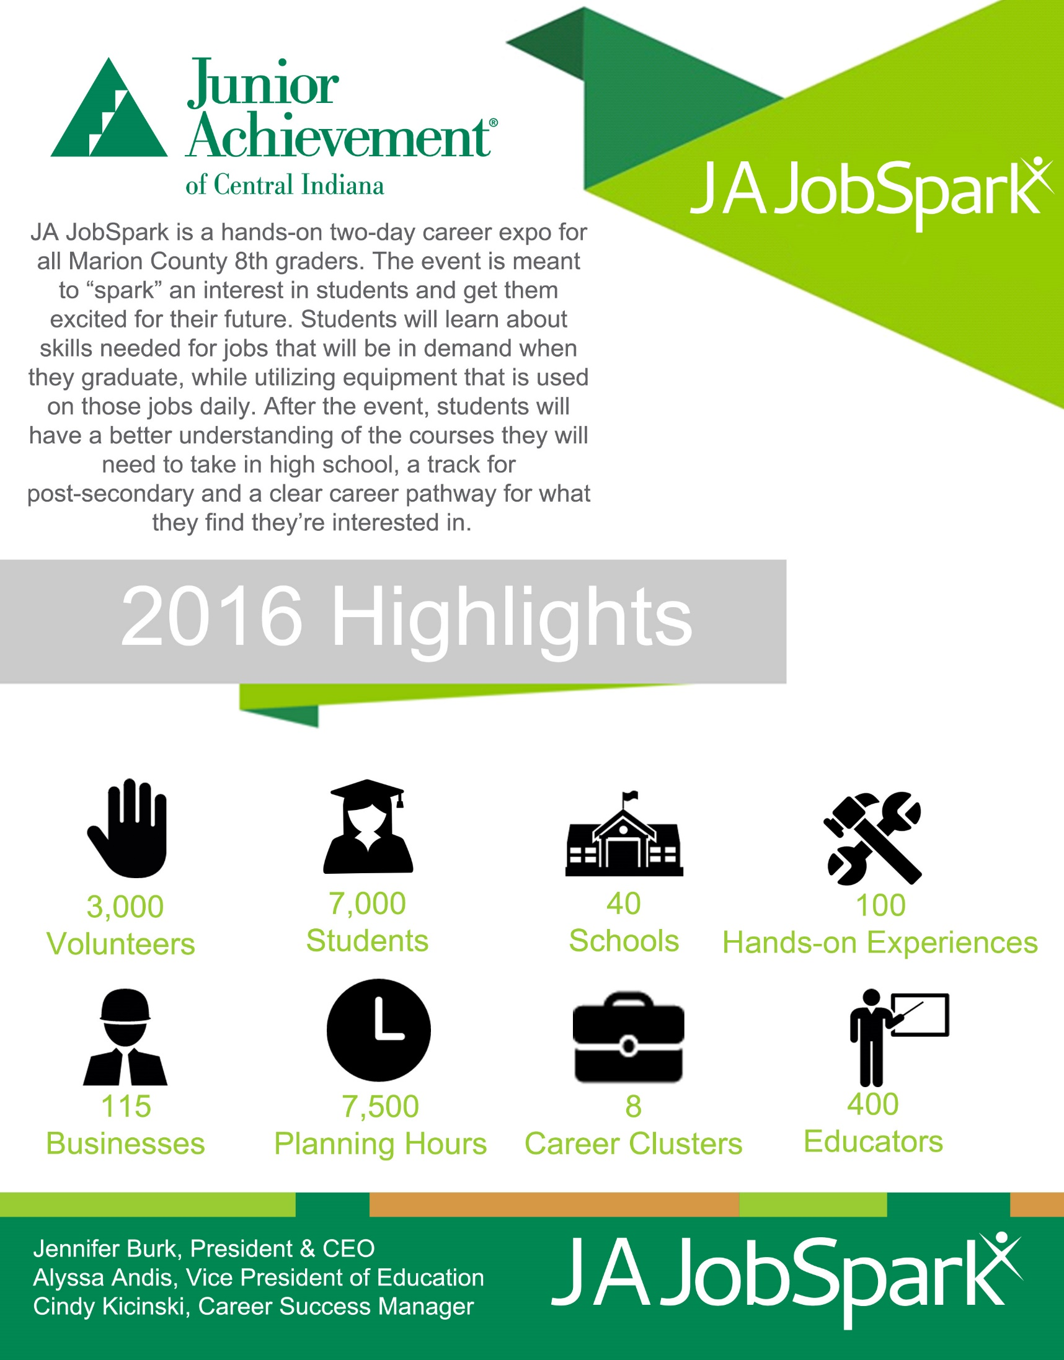
JA JobSpark: Hands on. Minds opened.

JA JobSpark is a coalition of educators and industry leaders, led by Junior Achievement of Central Indiana. At the center of our work is a two-day event that will be massive, measured both in square feet and impact.

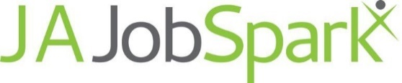

September 26-27, 2017
Indiana State Fairgrounds

Presenting (Click Here to Inquire)
- Company name in event title (i.e. 2017 JA JobSpark Presented by XYZ COMPANY)
- Logo printed on premier event items (Deadline June 1, 2017)
- Full page ad in student booklet (Deadline August 1, 2017)
- Opportunity to distribute company branded items
- Company listed on event promotional materials (emails, press releases, and printed publications)
- Sponsorship recognition at event through signage displaying logo
- Sponsorship recognition in student booklet displaying logo
- Company logo appears on the JA JobSpark website during the calendar year of the event
- Sponsorship recognition in community informational presentations

Diamond $25,000
- Logo printed on premier event items (Deadline June 1, 2017)
- Half page ad in student booklet (Deadline August 1, 2017)
- Company listed on event promotional materials (emails, press releases, and printed publications)
- Sponsorship recognition at event through signage displaying logo
- Sponsorship recognition in student booklet displaying logo
- Company logo appears on the JA JobSpark website during the calendar year of the event
- Sponsorship recognition in community informational presentations

Platinum $15,000
- Quarter page ad in student booklet (Deadline August 1, 2017)
- Company listed on event promotional materials (emails, press releases, and printed publications)
- Sponsorship recognition at event through signage displaying logo
- Sponsorship recognition in student booklet displaying logo
- Company logo appears on the JA JobSpark website during the calendar year of the event
- Sponsorship recognition in community informational presentations

Gold $10,000
- Sponsorship recognition at event through signage displaying logo
- Sponsorship recognition in student booklet displaying logo
- Company logo appears on the JA JobSpark website during the calendar year of the event
- Sponsorship recognition in community informational presentations

Silver $5,000
- Company listing at event through signage displaying name
- Company listing in student booklet
- Company listing appears on the JA JobSpark website during the calendar year of the event
- Sponsorship recognition in community informational presentations

Bronze $1,000
- Company listing in student booklet
- Company listing appears on the JA JobSpark website during the calendar year of the event

Junior Achievement of Central Indiana

September 26-27, 2017
Indiana State Fairgrounds

Sponsorship Reservation Form

PRESENTING SPONSOR (Click Here to Inquire)

DIAMOND SPONSOR - $25,000

PLATINUM SPONSOR - $15,000

GOLD SPONSOR - $10,000

SILVER SPONSOR - $5,000

BRONZE SPONSOR - $1,000

Contact: Phone: Company: Email: Address: City/State: Zip Code: Signature: Date:

PAYMENT OPTIONS: Send Invoice
Check Enclosed
Credit Card

Amount $ Account # Exp Date CV2 Code Name on Card Billing Zip Code

Please complete and return this form by fax or email to: For questions regarding sponsorships, please contact: Amy Tobias: Fax 317-218-3493 | amy@jaindy.org Amy Tobias: 317-252-5900 Ext 2 | amy@jaindy.org or by mail to:
Junior Achievement of Central Indiana, Inc. For questions or information regarding other event
9449 Priority Way West Drive, Suite 100 details, please contact:
Indianapolis, Indiana 46240 Cindy Kicinski 317-252-5900 Ext 7 | cindyk@jaindy.org

(Please return this form by June 1, 2017 to secure ad space)

