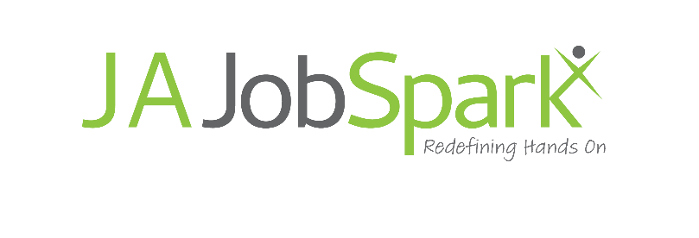
Social Media

During event days, create content for social media for your assigned cluster, and send to the provided email address for JA staff to upload to social media channels.

Virtual Platform Link: www.jajobspark.org/curriculum
Click on “Enter JA JobSpark” button
Volunteer Access Code: 0011

To view on-demand content:
- Login to the Virtual Platform
- Click on a cluster
- Click on the Career Paths sign
- Click on a pathway
- Click on a video to check out to include in your social media posts

To view live sessions:
- Login to the Virtual Platform
- Click on a cluster
- Click on the Live Session sign
- Click on a live session on the schedule to checkout/join the zoom to include in your social media posts

- Use social media toolkit below for inspiration or create your own post content
- Send screenshots of virtual platform
- Send screenshots of experiences, both on-demand and live
- No student names or student photos (shouldn’t be on site anyway)
- Screenshots of volunteers are encouraged (along with names/company names)
- Send all content to jajobspark@jaindy.org
- And include – your name and cluster name in subject line
- Please send content throughout the day so JA can post on social media in real time

Example:

Text: Junior Achievement is so excited about #jajobsparkindy! Students will have the opportunity to virtually tour 8 different career clusters and learn about jobs that will be in demand when they graduate. (add photo with text)

Social Media Toolkit

Share our messages: Twitter/Instagram
General:
- We are so excited for #jajobsparkindy! Never underestimate the power unleashed by a single spark. http://www.jajobspark.org
- Our goal is to impact the lives of students and how them how their talents & passions can cause a spark. @JACentralInd
- @JACentralInd’s #jajobsparkindy ensures that students understand their potential for the future. For more details, visit http://www.jajobspark.org
- When our young people know where they’re going, we all advance. That’s why I can’t wait to be a part of @JACentralInd’s #JAJobSparkIndy.
- Our goal is to show students how their interests, talents and passions can fulfill a future role in our community. @JACentralInd #JAJobSparkIndy
- The @companyname supports @JACentralInd’s #JAJobSparkIndy because it is preparing our students for our future workplace talent demands.
- @companyname believes the experiences we create at @JACentralInd’s #JAJobSparkIndy will prepare our future workforce with the right tools of success.
- @companyname/sponsor(s) @JACentralInd’s #JAJobSparkIndy because we know that their approach inspires kids to think outside the box when it comes to careers.
- We believe @JACentralInd’s #JAJobSparkIndy is a great educational tool that gives students real insight into several career opportunities.
- I volunteer with @JACentralInd’s #JAJobSparkIndy because it is amazing to watch kids learn they can have a future that fits their interests. #education
Cluster specific messages: (please pair with a photo relevant to each cluster)
- For students who are creative and like inventing things, the Advanced Manufacturing, Engineering and Logistics cluster is the place to be at #JAJobSparkIndy!
- Students interested in working outside or with animals have a variety of experiences to check out in the Agriculture, Food and Natural Resources cluster at #JAJobSparkIndy!
- Dreaming of designing a new building. Students are learning in the Architecture, Engineering and Construction cluster at #JAJobSparkIndy!
- Students who are interested in how businesses work are checking out the Business & Finance cluster at #JAJobSparkIndy!
- Are you willing to serve others? The Government, Law and Public Service cluster at #JAJobSparkIndy teaches about jobs that can be found
- Students who love science are enjoying the Health and Life Sciences cluster at #JAJobSparkIndy!
- Plan for big events in the Hospitality and Tourism cluster at #JAJobSparkIndy!
- For students who love learning about the latest tech, the Technology cluster is the right fit at #JAJobSparkIndy

Share our messages: Facebook

General: (please mention @JACentralInd in your posts if you can!)
- As one of the voices of the regional business community, the @companyname supports @jacentralindiana’s #JAJobSparkIndy because we know it prepares our students for the forecasted future workplace talent demand.
- @jacentralindiana’s #JAJobSparkIndy ignites ideas - the idea that students can take the educational path that suits him/her and find a career path that will be in-demand when they are ready.
- @companyname/We sponsor(s) @jacentralindiana’s #JAJobSparkIndy because we know that their hands-on approach inspires kids to think outside the box when it comes to potential career opportunities.
- We believe @jacentralindiana’s #JAJobSparkIndy is a great educational tool that gives students real insight into several career opportunities.
- I volunteer with @jacentralindiana’s #JAJobSparkIndy because it is amazing to watch kids learn they can have a future that fits their interests. #education
- #JAJobSparkIndy helps educate young people about careers in demand.

